Pay Day, Inc.

FUNCTION: Adding direct deposit to new client’s
DATE IF REVISION: January 27, 2014
REPLACES REVISION of: June 10, 2013

- Log into Evolution
- Go to Employee – Scheduled E/Ds
- Click the Open Company button (no necessary if it is grayed out)
  - 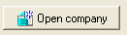
  - You will be brought to the “Browse Scheduled E/Ds Tab” for your first listed employee
- Click the Next or Prior buttons to scan through employees
- Once the employee that you want to direct deposit to is displayed, click the Green create new record sign at the top of the screen
- You will be brought to the Details 1 tab
  - E/D Code = Code for appropriate account type. Example, D90 for Checking, D95 for Savings
  - Calculation Method = If the employee wants 100% of their net to go to 1 account. This field should be coded to “None”. (This is the last option on the list)
    - If the employee only wants a portion of their check to go to this account, mark the field appropriately by the code type. Example. “Fixed”, will be a set dollar amount. “% of Net” will be a portion of the net amount calculated
  - Amount = If “None” was selected for the Calculation Method, then this field cannot be adjusted. If another calculation type was selected, this field should be used to determine the value. Example: If the employee wants $50 to go to one account, than the Calculation Method would be “Fixed”, and the Amount would be $50
  - Deduct whole Check = Yes
    - 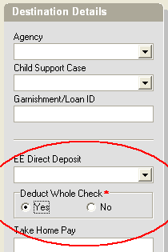
- Go to the Direct Deposits tab
  - Click on the green Create button on the middle of the screen
    - 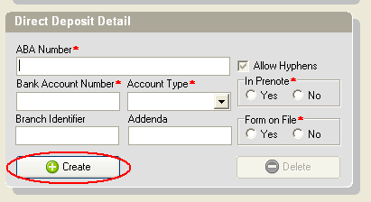
  - “You have attached the currently selected Direct Deposit! Please verify this is correct!”
    - Click OK
  - Routing/ABA Number = 9 digit routing number
  - Bank Account Number = Employee’s direct deposit account number
  - Account Type = Employee’s direct deposit account type
  - In Prenote = NO
  - All other settings stay the same
  - Click the Green Checkmark
- Go back to the details 1 tab
  - Verify the Routing/ABA # and account information now listed under EE DIRECT DEPOSIT
- If the information is now correct. Click the Commit Changes button
  - 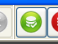

How to confirm this worked properly
- While inputting your next payroll, and after inputting all employee hours and wages, double click on the name of the employee whose direct deposit information was recently entered
- At the bottom of the screen, click the Recalculate Check button
  - This will take a moment to load then bring you to the Preview Tab
- This screen will now populate with an previewed check. In the second column, on the top it will show if the check will be direct deposit
  - Example: 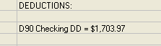
- If an amount is shown on the bottom net to “Net Amount”, then the check is not going 100% to direct deposit
- If the information shown looks correct, click the Batch Button in the bottom left to be brought back to the Quick Entry tab
- Keep in mind that when you now check your totals, you will show an amount for direct deposit of the employee(s) whose checks you recalculated

