Pay Day, Inc.

FUNCTION: Running Reports
DATE IF REVISION: February 3, 2011
REPLACES REVISION of: October 9, 2010

- Click on Reports – Run Reports
- Click Open Company Button
- You will see all of the reports listed on the right side
- Select the reports you want to view (by putting a check mark next to the report name) typically:
  - Check Reconciliation (S214)
  - Cover Letter (S193)
  - Payroll Register (S109)
- Click on the Report Parameters tab (this will take a moment to open)
- 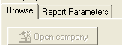
- Select the payroll you would like to print by putting a check mark in the box next to the check date, selecting multiple reports will combine the information in one report
  - When trying to select from multiple dates. You want to select with payroll with a Type of R (regular)
  - If you want to process reports for a select period, adjust the dates as shown below.
    - 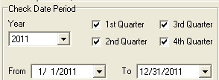
  - To select payrolls for a range of periods, click on the Blue box located above the column that check marks are placed in. A menu will appear as below.
    - 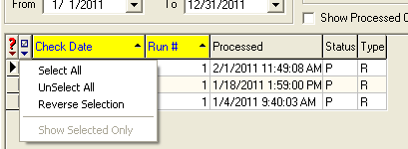
- To adjust settings for the report click on the Misc Tab at the top (when available).
- Change the “Print” to “Preview” (on top right) to bring the report up on screen.
- Below that, take the check mark OUT of Run through the Queue
- Click the Run Report button (on top right)
- Your report will be brought up on the screen.
- To save, click the green diskette on the top left hand corner of the screen.
- When saving, be sure to change the save as type to a PDF.
- Click the Red X at the top right to close out of the report.

