Pay Day, Inc.

FUNCTION: Printing/Saving quarterly & annual returns in Evolution
DATE IF REVISION: November 17, 2011
REPLACES REVISION OF:

- Printing copies of quarterly/annual returns.
  - Go to Tax Reports – Tax Returns
  - Change the “Period” to reflect the quarter you want to print.
    - 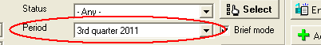
  - Change the Frequency to select quarterly or annual reports.
    - 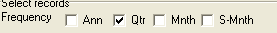
  - Click the Select Button to the right of the period.
  - After Loading, you will be brought to the Printing Settings Tab
    - 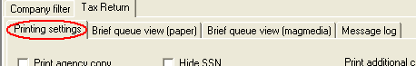
  - Put a check mark next to “Print Client Copy”
    - 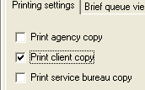
  - Go to the next tab to the Right. “Brief queue view (paper).
  - Click your company’s name on the left of the screen.
    - You will notice the arrow to the left of the company number will look as it does below.
    - 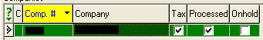
  - Click the Reprint Button in the bottom Right of the screen.
    - Your quarterly reports should automatically be sent to your printer.
- If you would now like to print another quarter:
  - Change the period at the top of the screen to show the new quarter you would like to print.
  - Click the “Refresh” button to the right of the period.
  - Follow steps H through I from above.
- Processing Electronic copies of returns.
  - Go to Tax Reports – Tax Returns
  - Change the “Period” to reflect the quarter you want to print.
    - Remove the Check Mark from Brief Mode next to the Period
  - Change the Status (Above the Period) to show “Processed”
  - Change the Frequency to select quarterly or annual reports.
  - Click the Select Button to the right of the period.
  - You will be brought to the General Queue tab.
  - Go to the Edit Queue Tab
  - Select the reports you want to save
    - To view all reports on the screen, click the button shown below.
      - 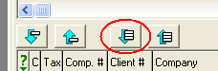
      - This will bring all of your reports to the bottom of the screen.
    - To view only certain reports.
      - Double click on the report on the top of the screen, the report will then move to the bottom.
  - Go to the Printing Settings tab.
    - Put a check mark in Print Client Copy
  - Go to the Process/Print tab.
    - Put a check mark in the Preview button on the bottom right of the screen
    - 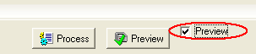
    - Click the Preview button located to the left of the check mark.
  - Your Reports will appear on the screen.
  - To password protect your returns:
    - Click the Golden Key at the top left of the screen
    - Security level = One Password
    - Full Access Password = Your selected Password
    - Click OK
    - Confirm your password
  - To save your quarterly returns.
    - Click the green diskette at the top left of the screen
    - File Name = What you would like the file to be saved as.
    - Save As Type = PDF (Be sure to change this from the default setting of .rwa)
    - Click Save
  - Go Back to the Edit Queue Tab
    - Click the arrow on the right to move all of your files back to the top.
    - 