Pay Day, Inc.

FUNCTION: Workers Compensation Audit
DATE IF REVISION: October 3, 2013
REPLACES REVISION of:

This procedure will show you how to generate the payroll information for most Workers Compensation Audits

- Have your policy effective dates and the dates the audit is requesting
  - Apply your audit dates to the procedure below
- Processing Selected Quarterly Annual Returns
  - Go to Tax Reports – Tax Returns
  - Change the “Period” to reflect the quarter you want to print
    - 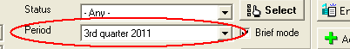
    - Remove the Check Mark from Brief Mode next to the Period
  - Change the Status (Above the Period) to show “Processed”
  - Change the Frequency to select quarterly or annual reports, depending on what’s required for your audit
    - 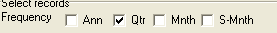
  - Click the Select Button to the right of the period
  - You will be brought to the General Queue tab
  - Go to the Edit Queue Tab
  - Select the reports you want by double clicking each one, the report will then move to the bottom
    - 941 (you will need 4 quarters for the audit)
    - State Unemployment forms (you will need 4 quarters for the audit)
      - Rhode Island = RI-TX-17 Return
      - Massachusetts =
        - MA Form 1 Return
        - MA WR-1 Wage Return
      - Connecticut = CT UC2 & 5B Quarterly UI Return
  - Go to the Printing Settings tab
    - Put a check mark in Print Client Copy
    - 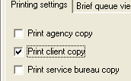
  - Go to the Process/Print tab
    - Put a check mark in the Preview button on the bottom right of the screen
    - 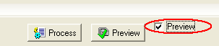
    - Click the Preview button located to the left of the check mark
  - Your Reports will appear on the screen
    - Click the printer icon if you want to print them continue to step m otherwise to step o
  - To save - password protect your returns
    - Click the Golden Key at the top left of the screen
    - Security level = One Password
    - Full Access Password = Your selected Password
    - Click OK
    - Confirm your password
  - To save your quarterly returns
    - Click the green diskette at the top left of the screen
    - File Name = What you would like the file to be saved as
    - Save As Type = PDF (Be sure to change this from the default setting of .rwa)
    - Click Save
  - Go Back to the Edit Queue Tab
    - Click the arrow on the right to move all of your files back to the top
    - 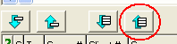
- Processing a payroll register for the entire year
  - Click on Reports – Run reports
  - Choose payroll register on the right
  - Click on report parameters
  - Set the Check date period = the dates for your audit or dates of your policy, whichever your audit requires
  - Click on the small blue box to the right of the red question mark 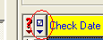
  - Choose select all
  - Click on the Misc Tab
    - next to Show only Summary for Multiple check dates
  - Printing Saving report
    - To Save the report electronically
      - Change print to preview (box next to run report button)
      - Click on Run report
      - Click on the view button on bottom left under the exit button
        - To password protect your report:
          - Click the Golden Key at the top left of the screen
          - Security level = One Password
          - Full Access Password = Your selected Password
          - Click OK
          - Confirm your password
        - To save your report
          - Click the green diskette at the top left of the screen
          - File Name = What you would like the file to be saved as.
          - Save As Type = PDF (Be sure to change this from the default setting of .rwa)
        - Click the red X to close the view queue
    - To print the report
      - Change the preview to print (box next to run report button)
      - Click on Run report
      - The report will print
  - This should be everything you need for most insurance company audits

